Temasek Polytechnic
School of Informatics and IT

Diploma in Information Technology (IT)

Software Requirement Specifications (SRS)

Project Particulars

Tutor | Mr Qi Yutao
Class | P01
Project Title | Delonix Regia Hotel Management System

Project Team’s Particulars

Matric Number | Student Name
1303140F | Jaelyn Lim Hui Wen
1304174D | Leong Min En
1303084F | Loh Shi Jia, Serene
1306932C | Reyner Leong

Revision History

Date | Version | Description | Author
11/05/15 | 1.0 | Documented User Characteristics, Data Requirements, Interface with Other Systems, Performance | Jaelyn Lim Hui Wen
11/05/15 | 1.1 | Documented System Functions, Functional Requirements, Assumptions, Operating Environment, Security and Access Control Requirements | Loh Shi Jia, Serene & Reyner Leong
11/05/15 | 1.2 | Documented General Constraints, User Interface Requirements, Development Constraints, Availability | Leong Min En & Reyner Leong
14/05/15 | 2.0 | Updated User Characteristics, Data Requirements, Interface with Other Systems, Performance | Jaelyn Lim Hui Wen
14/05/15 | 2.1 | Updated System Functions, Functional Requirements, Assumptions, Operating Environment, Security and Access Control Requirements | Loh Shi Jia, Serene
14/05/15 | 2.2 | Updated General Constraints, User Interface Requirements, Development Constraints, Availability | Leong Min En
17/05/15 | 3.0 | Updated Assumptions, Operating Environment, Availability | Reyner Leong
17/05/15 | 3.1 | Updated Data Requirements, Performance, Development Constraints | Jaelyn Lim Hui Wen
17/05/15 | 3.2 | Updated System Functions, Functional Requirements, Security and Access Control Requirements | Loh Shi Jia, Serene
17/05/15 | 3.3 | Updated User Interface Requirements | Leong Min En

Table of Contents

1. DISTRIBUTION OF WORKLOAD 4
2. OVERVIEW OF REQUIREMENTS 5
2.1 System Functions 5
2.2 User Characteristics 6
2.3 General Constraints 8
2.4 Functional Requirements 8
2.4.1 Login and Logout 8
2.4.2 Room Availability and Booking Module 8
2.4.3 Housekeeping and Staff Management Module 11
2.4.4 Reporting Module 12
2.4.5 User account and login creation Module 13
2.4.6 Searching Rooms 13
2.4.7 Guest profile and history module 13
2.4.8 FAQs 14
2.5 Data Requirements 15
2.6 User Interface Requirements 21
2.7 Interface with Other Systems 28
2.8 Assumptions 28
3 OPERATIONAL AND QUALITY REQUIREMENTS 29
3.1 Operating Environment 29
3.2 Development Constraints 30
3.3 Performance 30
3.4 Availability 31
3.5 Security and Access Control Requirements 31
4 REFERENCES 34

DISTRIBUTION OF WORKLOAD

Requirement Gathering | Members
System Functions | Loh Shi Jia, Serene
User Characteristics | Jaelyn Lim Hui Wen
General Constraints | Leong Min En
Functional Requirements | Loh Shi Jia, Serene
Data Requirements | Jaelyn Lim Hui Wen
User Interface Requirements | Leong Min En
Interface with Other Systems | Jaelyn Lim Hui Wen
Assumptions | Loh Shi Jia, Serene & Reyner Leong
Operating Environment | Loh Shi Jia, Serene & Reyner Leong
Development Constraints | Leong Min En & Jaelyn Lim Hui Wen
Performance | Jaelyn Lim Hui Wen
Availability | Leong Min En & Reyner Leong
System and Access Control Requirements | Loh Shi Jia, Serene

OVERVIEW OF REQUIREMENTS

System Functions
The owners of Delonix Regia’s Hotel, Mr. and Mrs Wang has instructed us to create a Hotel Management System (HMS) for the hotel. Despite being located a good location, the business has not met up with the expectations. With implementing HMS, it will definitely assist the owner and the staff in the hotel to manage daily operation more efficiently.
Reservation Management, track other revenue services, rate control, generating reports and customer management, Employee and Housekeeping Tracking, Invoices and Statements, Flexible Payment Options by using dashboard and calendar.
The following are the functions that are going to be implemented into the system.
- Reservation System
  - Creating and updating individual, group and business block reservations, including deposit handling, cancellations, confirmations, wait listing, room blocking and sharing
  - Handles individual guests, groups and walk-ins, room blocking, managing guest messages and wake-up calls
- Customer Management
  - Keep track of regular customers on how much they are spending or what are their preferences
  - Save customer’s details such as their email addresses for future email newsletters and promotional campaigns
- Reporting System
  - Creates reports that give user the visibility into success of their property’s marketing
  - Generate any report that the user wants E.G. RevPar reports
  - Create reports in-browser, email reports or download spreadsheets and PDFs
- Employee and Housekeeping Tracking
  - Record important activities and the employees responsible for them, keeping the employees accountable for their actions
  - Handles all facets of room supervision including availability, housekeeping, maintenance and facility management
- Invoices and Statements
  - View, review, or print invoices and statements
  - Group invoices together to manage the corporate or group accounts more easily
- Global Perspective
  - Support multi-currency and multi-language as rates and revenues can be dynamically converted from the local currency to any other currency and the appropriate language for guest can be automatically determined by the guest’s profile language
- Flexible Payment Options
  - Integrates with dozen of payment gateways and supports all major credit cards and even PayPal

User Characteristics
There are 4 types of users that will be interacting with the system:
- Hotel owners (Mr & Mrs Wang)
Role: They manage the hotel by ensuring that the hotel is progressing and generating revenues with the help of the reports. They will be in charge of the invoices and statements of the hotel.
Characteristics: They should know how the hotel management system work and be able to generate the invoices and statements through the system. They are also required to understand what the invoice and statements generated are about.

- Staff
- Manager
Role: They manages the hotel by generating reports for each department and are responsible for creating, updating employee’s information and assign employee roles in the hotel.
Characteristics: Know how to use the functions provided in the hotel management system to generate reports in-browser, email reports or download spreadsheets and PDFs
- Receptionist
Role: They are the staff working at the front desk who are mainly responsible for the booking, reservation and request of customers such as customer messages, wake-up calls or room services.
Characteristics: They should be able to work well with IT products, such as a personal computer or a smart phone.
- System Administrator
Role: They are responsible for the security and maintenance of the hotel management system, ensuring that the uptime, performance and resources of the system meet the needs of the users.
Characteristics: They should be knowledgeable in the software engineering process and have good understanding of the tasks, activities and artifacts that are being involved with the system. They should also be skilled in IT expertise such as knowing how to maintain, upgrade, configure or troubleshoot a system.
- Customers
Role: They are able to make an online booking or reservation for the hotel services available through the internet on their own. Customers are also able to search for and select their own rooms from the rooms that are available in the hotel.
Characteristics: They should know how to access hotel website and how to make an online booking. They are also required have a credit card or an account online that allows them to make payment through the internet as they will have to make payments online during the booking session.

General Constraints
The System shall be a stand-alone system running in a Windows and Macintosh environment. The system shall be developed using Microsoft Visual Studio. Text files shall be used for all data storage and reporting.The developer and client must be able to operate with a minimum 512Mb, best 1GB.

Functional Requirements

Login and Logout
- The system will allow all users to login and logout of the system.
Login
  - The system will prompt the user for the login details; Staff ID and login password.
  - The system will check if the provided login details match with the login details in the database.
  - If there is a match found, the staff homepage page is loaded
  - If there is no match found, an error message will be displayed to inform the user to try again.
Logout
- The system will log the user out when the user clicks on the “Logout” button.

Room Availability and Booking Module
Room Availability Management
- The system will allow users (i.e. reception staff) to manage check-ins and checkouts.
- The system will be able to check hotel room availability and will allocate respective rooms to the respective guests.
- When checking out, additional charges will be recorded so that the total payable amount can appear for the guest to see.
Check-in
- The system will prompt user with guest identification number.
- With the identification number, they will be able to view the booking that was made. The booking will include the booking id, first name, last name, contact number, home and mailing address, email address, number of adults, number of children, type of room, check-in date and time, checkout date and time, payment type, credit card type, credit card number, credit card expired date and additional remarks.
- If unable to find identification number with a booking, user will be shown an error message.
- If able to find identification number with a booking, guest will be able to go to their rooms and the room status of that particular room will change from ‘Available’ to ‘Occupied’.
Checkout
- The system will prompt for the guest identification number
- Upon providing the identification number, the user will be able to view the room rates and add on the additional charges.
- Upon checking out, the booking will be deleted from the system and an invoice will be generated.
- After the guest has checked out, the room status will change from ‘Occupied’ to ‘Available’.
Room Booking Management
- The system will allow users (i.e. reception staff) to manage guest bookings via call-in.
- Guests can make booking through online themselves too.
Create booking
- The system will display the following details when the user wants to create a new room booking; first and last name, contact number, home and mailing address, email address, number of adults, number of children, type of room, check-in date and time, checkout date and time, payment type, credit card type, credit card number, credit card expired date and additional remarks.
- Users will be able to view the different room types and respective rates before entering their final decision
- Upon choosing the room type, the room rate will be automatically displayed on the web page itself.
- Upon entering all this details, the system will generate a booking ID.
- Together with the above information provided and generated booking ID, these details will be saved into the Booking database table.
- The system will be able to proceed to the next step of the booking even if the credit card details are not entered as long as payment type is not ‘Credit Card’.
- The system will only accept inputs of a regular expression for credit card number (16 numeric digits) and credit card CVC code (3 numeric digits). Failing which, an error message will be displayed to the user regarding the number of digits.
- After creating a new booking, user will be required to verify themselves with a PIN number that will be sent to their email address.
- As they make the booking, the booking will be stored as a log file.
View/Update/Delete booking
- The user will have to provide the system with a booking id before being able to view, update or delete the booking.
- As long as the booking has not reached the check-in date, the users are able to update or delete the booking.
- Once the user clicks on the delete button, the booking will be deleted from the database table and system as well.
- The user will have to verify themselves once again with a PIN number that will be sent to their email address if they decide to update the booking.
- The system will display an error message if the user does not select a particular booking id before clicking on the update or delete button.
- Once the information is updated, the new information will overwrite the old one in the database and the system as well.

Housekeeping and Staff Management Module
Housekeeping management
Guests housekeeping Requests
- The system will allow for the guests to make special housekeeping requests.
- The system will allow for the housekeepers to track and monitor these housekeeping requests for completion.
- As they finish the housekeeping of each room, they will be able to update the status too.
- The guests will be able to check the housekeeping status of their own rooms
- The request will contain of the following information; request date and time, room number and request.
Staff Schedule
- The system will allow the user to add new staff schedule, view, update or remove existing ones.
- The information required for new staff schedule are staff ID, staff name, duty type, room number and duty date and time.
- The system will then generate a housekeeping id which will be stored in the database with the above information as well.
- The system will reduce input from user as to making mistakes, by retrieving information from the staff database table when the staff ID is entered.
- When the user wishes to edit, or delete the staff schedule, the user will have to provide housekeeping id.
- If the housekeeping id is recognized by the database, the update or delete will be successful.
- If the housekeeping id is not recognized by the database, there will be an error message displayed.
Staff management
- The system will allow the management and administrators to access staff information.
Hotel Staff
- The system will prompt the user for staff details when adding new hotel staff. The details that have to be provided are staff name, login password, dob, bank type, bank account number, home and mailing address, email address, contact number, staff duty type and the user access level.
- After entering all these details, the system will generate a staff id for the new staff and save it together with the above information.
- The system will only allow for the login password to be entered if the user is the administrator.
- When the user wants to view, update or delete a hotel staff, they will need to provide the system with the staff id.
- If the staff id does not exist in the database, an error message will be displayed.
- If the staff id does exist in the database, they will be successfully able to view/update or delete the staff information.

Reporting Module
- The system will display all the reports available to generate on this page. However it will depend on the users’ access level:
All users:
- Room Status report
- All guests in a room report
- All guests in all rooms report
Management users & administrators:
- Room occupancy report
- Housekeeping report
- Before loading this page, the system will confirm the type of user and the access level it has, thus giving options which are available to them only.
- The system will load the particular report after generating it.
- The user will also have an option to preview the report and then to print it as well.
- The report will have additional information; report generated date and report date range.

User account and login creation Module
- The system will allow only administrators to manage user accounts and login creations.
- Only the administrator (i.e. Mr Wang) has the authority to register new staff and guest accounts, edit them or delete them as well.

Searching Rooms
- The system will allow guests to search for rooms within their budget.
- User will have to provide system with desired budget.
- The system will then check available rooms and rooms types with their room rates matching as closely as possible with their budget.
- If there are no rooms available for the period they are looking for it, an error message will be displayed.

Guest profile and history module
- The system will allow all users to manage the guest profile which is also the guest information.
- The guest information would be normally stored when bookings are being made.
- If there are repeat guests making booking, in order to save trouble to re-enter all the guest details, the details will be automatically loaded in for them.
- The history will allow users to view the previous bookings made together with their choice of preferences as well so as to ensure they receive a good stay the next time they come to visit again.

FAQs
- The system will allow the guests to type in their queries on this page which will be stored in the database along with their email address.
- After which, the users (i.e. management users and administrators) will be able to view this FAQs and reply to them.

Data Requirements

Table Name | Staff
Name | Data Type | Description | Example | Primary Key | Foreign Key
staffid | Char(8) | The unique identity of a staff. | R1234567 | Yes | No
name | Varchar(50) | The staff’s full name. | Leo Ang | No | No
nric | Char(9) | The staff’s NRIC. | S1234567B | No | No
dob | Date | The staff’s date of birth. | 18/2/1987 | No | No
email | Varchar(50) | The staff’s email address. | leo@live.com.sg | No | No
address | Varchar(100) | The staff’s home address. | Blk 123  Ang Mo Kio Ave 6 Singapore 123266 | No | No
contactno | Char(8) | The staff’s phone number. | 98651245 | No | No
banktype | Varchar(50) | The type of bank account which the staff’s bank account belongs to. | Savings | No | No
bankaccno | Char(10) | The staff’s bank account number. | 0013267895 | No | No
loginpassword | Varchar(50) | The password used for the staff to login to the hotel management system. | Password123 | No | No
useraccesslevel | Varchar(20) | The types of staff. | Users/Management Users/Administrator | No | No
departmentid | Char(4) | The unique identity of a department. | R123 | No | Yes

Table Name | Booking
Name | Data Type | Description | Example | Primary Key | Foreign Key
bookingid | Varchar(8) | The unique identity of a booking. | 1234567A | Yes | No
roomtype | Varchar(50) | The type of room that the customer is going to book for. | Single room, Double room, Twin room | No | No
noofroom | Int | The number of room the customer is going to book for. | 2 | No | No
noofadults | Int | The number of adults. | 4 | No | No
noofchildren | Int | The number of children. | 1 | No | No
checkindate | Date | The date that the customer is going to check-in to the hotel. | 11/04/2014 | No | No
checkoutdate | Date | The date that the customer is going to check-out of the hotel. | 20/04/2014 | No | No
totalamount | Decimal(7,2) | The total sum of the booking made. | 2364.00 | No | No
paymenttype | Varchar(15) | The type of payment the customer is making. | Credit Card, Paypal | No | No
creditcardtype | Varchar(50) | The type of credit card the customer is using to make the payment. | Visa, MasterCard | No | No
creditcardno | Char(16) | The customer’s credit card number. | 1472 0258 0399 9874 | No | No
cvc | Char(3) | The security code of the credit card. | 510 | No | No
cardholdername | Varchar(50) | The name of the owner of the credit card. | Anna Tan | No | No
cardexpirydate | Date | The credit card expiry date. | 13/06/2017 | No | No
remarks | Varchar(100) | Additional requests made by the customer to the hotel. | I would like to request for an additional bed. | No | No
pin | Char(7) | A unique PIN number. | 2235481 | No | No
customerid | Char(9) | The unique identity of a customer. | H9865123K | No | Yes

Table Name | Customer
Name | Data Type | Description | Example | Primary Key | Foreign Key
customerid | Char(9) | The unique identity of a customer. | H9865123K | Yes | No
firstname | Varchar(50) | The given name of the customer. | Dylan | No | No
lastname | Varchar(50) | The surname of the customer. | Koh | No | No
passportno | Varchar(9) | The passport number of the customer. | T4895142H | No | No
gender | Varchar(6) | The gender of the customer. | Female, Male | No | No
dob | Date | The date of birth of the customer. | 05/06/1964 | No | No
email | Varchar(50) | The email address of the customer. | dylan@yahoo.com | No | No
contatctno | Varchar(30) | The phone number of the customer. | 65 98745612 | No | No
nationality | Varchar(50) | The nationality of the customer. | Korean | No | No
country | Varchar(50) | The country that customer live in. | South Korea | No | No
checkindate | Date | The actual check-in date of the customer. | 11/04/2014 | No | No
checkintime | Time | The time the customer check-in to the hotel. | 14:25 | No | No
checkoutdate | Date | The actual check-out date of the customer. | 20/04/2014 | No | No
checkouttime | Time | The time the customer check-out of the hotel. | 10:45 | No | No

Table Name | Rooms
Name | Data Type | Description | Example | Primary Key | Foreign Key
roomno | Char(4) | The room number. | 1001 | Yes | No
roomtype | Varchar(50) | The type of room. | Single room, Double room, Twin room | No | No
roomrates | Decimal(5,2) | The rate of the room per night. | 269.00 | No | No
roomlevel | Int | The level the room is located on. | 6 | No | No
capacity | Int | The number of people the room is able to host. | 3 | No | No
status | Varchar(20) | The status of the room. | Available, Occupied | No | No
bookingid | Varchar(8) | The unique identity of a booking. | 1234567A | No | Yes

Table Name | Requests
Name | Data Type | Description | Example | Primary Key | Foreign Key
requestid | Varchar(7) | The unique identity of a request. | 1023485 | Yes | No
requestdate | Date | The date of the request made. | 03/04/2015 | No | No
requesttime | Time | The time of the request made. | 11:00 | No | No
request | Varchar(100) | The request made by the customer. | New towels, tidying and cleaning up of the room. | No | No
roomno | Char(4) | The room number. | 1001 | No | Yes

Table Name | Department
Name | Data Type | Description | Example | Primary Key | Foreign Key
departmentid | Char(4) | The unique identity of a department. | R123 | Yes | No
departmentname | Varchar(50) | The name of the department. | Reservation | No | No
noofstaff | Int | The number of staff in the department. | 57 | No | No
departmenthead | Varchar(50) | The name of the head of the department. | Jennifer Yeo | No | No

Table Name | Housekeeping
Name | Data Type | Description | Example | Primary Key | Foreign Key
housekeepingid | Char(6) | The unique identity of a housekeeping. | 26548F | Yes | No
staffname | Varchar(50) | The name of the staff assigned to the housekeeping. | Leo Ang | No | No
typeofduty | Varchar(50) | The type of work required to be done by the staff. | Tidying hotel rooms | No | No
date | Date | The date when the staff is required to do the work. | 24/09/2014 | No | No
time | Time | The time when the staff did the work. | 15:00 | No | No
staffid | Char(8) | The unique identity of a staff. | R1234567 | No | Yes
roomno | Char(4) | The room number. | 1001 | No | Yes

Table Name | FAQs
Name | Data Type | Description | Example | Primary Key | Foreign Key
email | Varchar(50) | The email of a customer whom ask the questions. | leo@live.com.sg | Yes | No
queries | Varchar(200) | The enquiries of a customer. | What is the earliest time to be able to check-in?, What is the latest time to check-out? | No | No

User Interface Requirements
Screen Name | Description
Login | Log into the system as a Customer or Administrator
Reservation | Retrieve button, save reservation, cancel reservation, modify reservation
Check-in (administrator only) | Check-in customer (with or without a reservation), adjust room rate, special requests,
Checkout (administrator only) | Checkout customer, generate bill
Room Service/Restaurant (administrator only) | Create order, modify order, view order, cancel order, generate meal bill
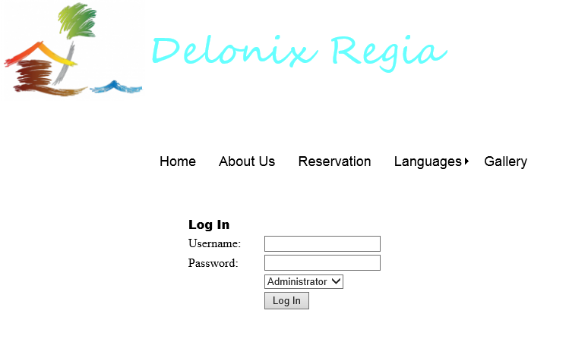
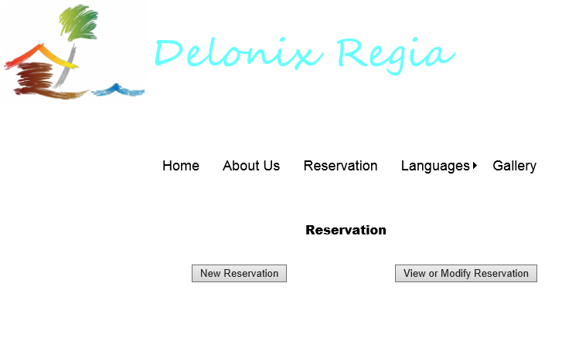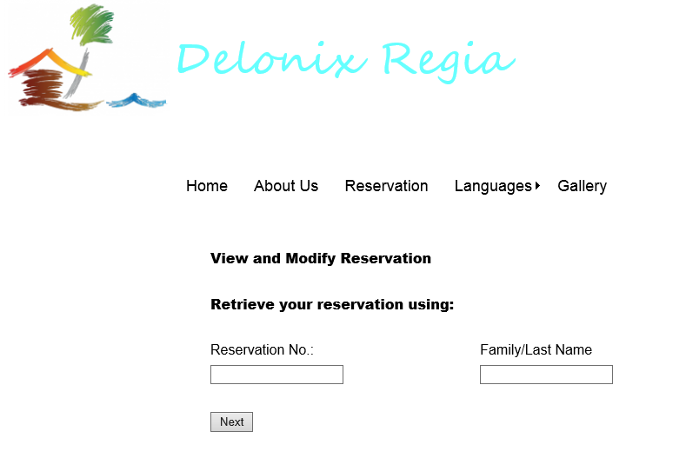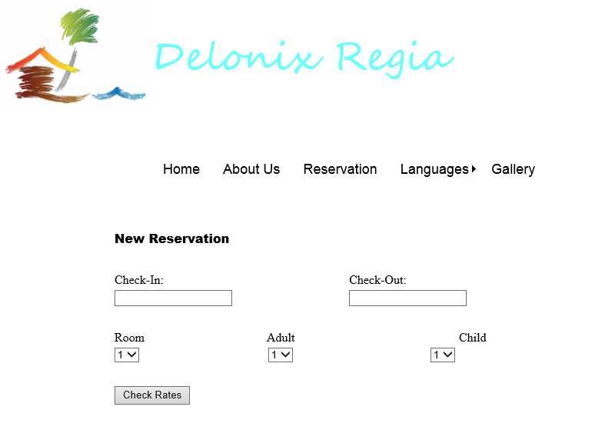
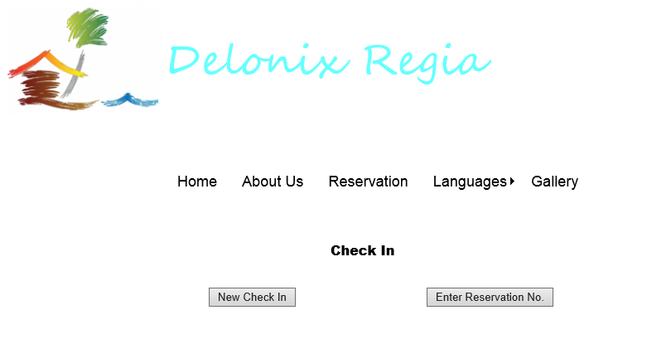

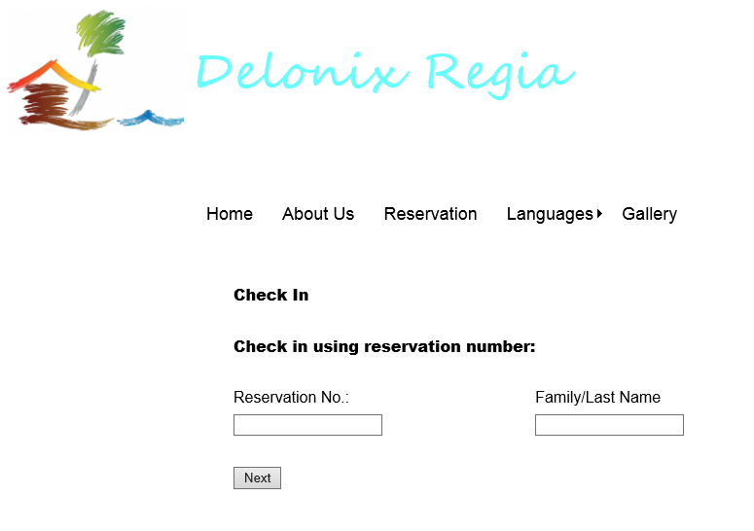

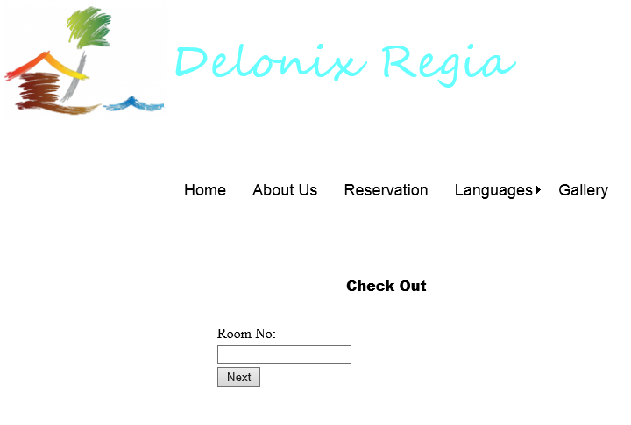

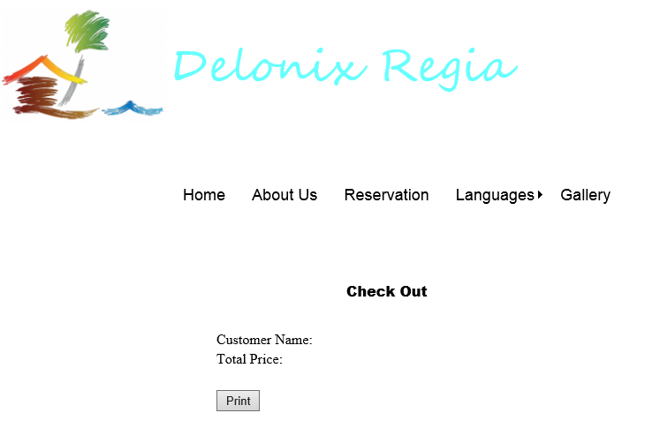
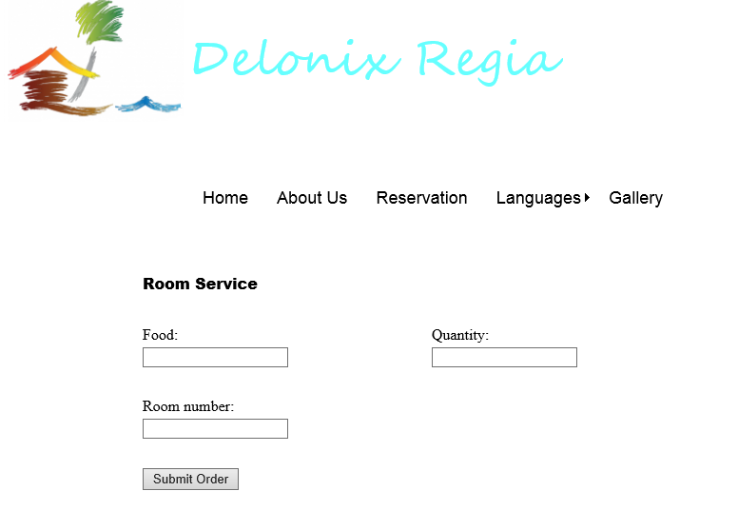

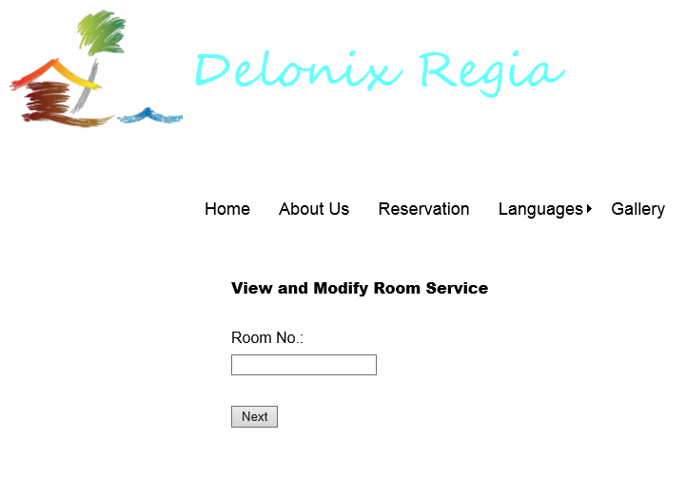
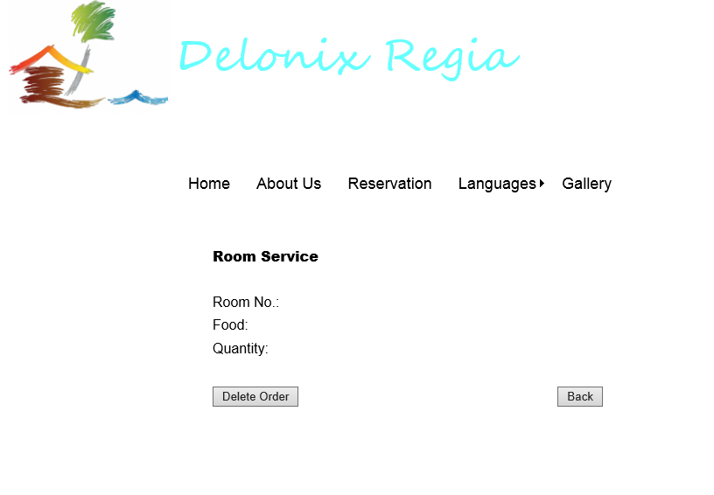

Interface with Other Systems
Data Transfer
Secure sockets will be implemented for all transactions made online this includes confidential information of customers.
Data Storage
Account log-in is required to retrieve, create, update and delete information stored in the database.
The propose hotel management system’s databases will be encrypted.

Assumptions
- The system is supposed to save the generated reports
- Able to retrieve them whenever needed
- Credit card payments are included
- Debit card payments are included

OPERATIONAL AND QUALITY REQUIREMENTS

Operating Environment
The operating environment that the hotel management system will be deployed on:
Integrated Development Environment (IDE)
- Pantheon Systems
- Visual Studio 2010 (Web applications)
- Eclipse Standard 4.3.2 (Mobile applications – Android platform)
- OS X & IOS (Apple Mac Platform & Mobile platform)
Hardware
1. Fully compatible with HP COMPAQ Tower Desktop PC – Computer used for reception staff area
- Intel® Pentium® 4 Processor 2.80 GHz, 512K Cache, 533 MHz FSB
- 1GB RAM
- 160GB Hard disk
- Windows XP Professional Edition Support Package 2 and above.
2. Any Android mobile devices - latest recommended android device (Samsung Galaxy S4)
- Android OS, v4.2.2 (Jelly Bean), v4.3, upgradable to v4.4.2 (Kit Kat)
- 1080 x 1920 pixels, 5.0 inches (~441 ppi pixel density)
- Supports up to OpenGL ES version 3.0
3. Any Mac OS & IOS devices (Apple Iphone 4 and above)
- Mac: OS X v10.6.8 or later
- IOS 7
- Operating system (OS)
1. Windows
2. Android
- Web Services & Networks
Must have Internet Connection
Internet Information Services (IIS)
Virtual private network (VPN) – For hotel staff to access management modules

- Database server
Microsoft SQL server management studio 2008

Development Constraints
- System software constraints
- Outdated systems software versions
- Incompatibility between software such as the operating system and programming language
- Issues with device drivers
- Hardware constraints
- Incompatibility between hardware and systems software
- Hardware restrictions
- Interoperability between hardware components

Performance
Dashboard: It runs on real time basis, if there is an update to an information in the database, changes will be made to all the information that are currently running simultaneously on other interfaces.
Reporting System: It will take 1 to 3 minutes for a report to be generated whereby the longer the report, the more time it takes to generate it. For example, an annual report take a longer time to generate than a monthly report.
Invoice and Statement: It will take around 1 minute for an invoice to be generated whereby the longer the invoice the more time it takes to generate it.
Reservation system: It only takes a single click and a second to create, retrieve, update and delete bookings and reservations.
Login and Logout: It only takes 3 seconds for a staff to log in or log out of the hotel management system normally. While it takes 6 seconds for a staff to log in or log out of the system during peak hour.
Global Perspective: When the user clicks on a particular language option, it will only takes 2 seconds for all the language presented in the browser to be translated to the language which the user had selected.
Flexible Payment: Different types of payments will always be available 24/7 for the users to select from.
Searching Rooms: It will only take 5 seconds for a list of available rooms that meets the requirements of the user to be generated.
FAQs: Queries send to system will be answered and email back to the users within 3 working days.

Availability
The system is required to run 24/7. The down time for maintenance and data backup will be at everyday 3am.

Security and Access Control Requirements
Access:
There are three main functions of the system; Room availability & booking module, Housekeeping & staff management module and the Reporting module. The users who have access to certain function differs.
End users (reception staff)
They can access parts of the reporting module. The parts of reporting modules and data that the end users may have access to is:
- Room statues report
- List all guest in a particular room report
- List all guest in all rooms at any given time report
Also, the end users have full access to room availability & booking module. This allows them to edit the guest records, view room availability and have access to all of the data in the room availability & booking module.
Management users
The management users have full access to all three modules; room availability and booking module, housekeeping and staff management module and reporting module.
Administrators
Administrators can have access to all parts of system as well.
Moreover, they have additional access to user account and login creation module. This module allows the administrator to gain control over all the accounts of the system, both guests and staff accounts. They can easily remove or add new accounts with this access. Currently, only Mr Wang is the administrator.
Auditing and Logging
The areas that would require logging for auditing purposes would be:
- When editing booking information. Every time, a cancellation of room booking or changing the booking period/ booking rooms. We would log the date and time of changes and the changes made.
- When staffs changes guest records. We would log the date and time of changes along with changes made.
- Every staff login. We would log the date, time, username and password (encrypted) of login.
- Every booking made. We would log the date, time, username and the booking details.
- Whenever any changes to any account’s personal information was made. We will then log the username, date, time, the changes made
- Registration for staffs. We would log the date, time, registration information and the administrator’s username.
- Whenever a report is generated. We would then log the date, time and the type of report generated.
- We would also log the room cleaning schedule.

Other Security
There are many other security considerations besides auditing and logging. These are some other security measures we would be implementing in the software:
- Encrypting/hashing all passwords and sensitive information regardless of account type is a must.
- We would also give a limited amount of tries for user login before locking the account for some time to prevent un-authorized personnel from entering the account.
- Also, implementing CAPTCHA during registration of accounts is necessary to prevent spam and bots.
- Encrypting data transfers (SSL)
- Using session timeouts. Give limited time for customer users to stay logged on. This is for preventing hackers targeting unlocked accounts.
- Furthermore, we can also send users their log files through emails every week. So that users can verify the actions they did on that week.

REFERENCES
http://www.academia.edu/2348821/Hotel_Management_System
http://www.ocr.org.uk/Images/143301-level-3-unit-35-system-development-requirements-and-constraints.pdf
http://cohesion.chrysocome.net/documentation/srs/
http://wwwis.win.tue.nl/2R690/projects/spingrid/urd.pdf
http://www.cse.chalmers.se/~feldt/courses/reqeng/examples/srs_example_2010_group2.pdf
http://www.slideshare.net/thissagamage1/srs-document-for-hotel-management-system
http://www.slideshare.net/vidya_shankar/hotel-managementsystemcorrectfinalsrs
http://www.academia.edu/2348821/Hotel_Management_System
http://www.information-management-architect.com/data-requirements.html
http://www.academia.edu/2112330/A_SAMPLE_HOTEL_MANAGEMENT_SYSTEM_PROJECT_DOCUMENTATION
http://www.engr.sjsu.edu/gaojerry/course/131/SampleProjects/Design_Doc.pdf
http://www.slideshare.net/Chetan2608/software-requirements-specification-of-library-management-system
http://www.scribd.com/doc/24482816/library-management-system-sds#scribd

